
Windows Virtual Desktop
Deployment Guide
Updated: 3/25/2020

Cognizant Microsoft Business Group
20 North Wacker Drive #530
Chicago, IL 60606

Notice of Confidentiality ©2021 Cognizant Microsoft Business Group All rights reserved.

IS SUBJECT TO THE TERMS OF THE COGNIZANT MICROSOFT BUSINESS GROUP NON-DISCLOSURE AGREEMENT. NEITHER THIS DOCUMENT NOR ITS CONTENTS MAY BE REVEALED OR DISCLOSED TO UNAUTHORIZED PERSONS OR SENT OUTSIDE THE AFOREMENTIONED COMPANY WITHOUT PRIOR PERMISSION FROM COGNIZANT MICROSOFT BUSINESS GROUP

Table of Contents
Summary 3
Deployment 3
Additional Administration Steps 9

Summary
This guide outlines the deployment of Windows Virtual Desktop. Before beginning, please verify that the requirements listed in the WVD overview documentation are met.

Deployment
To deploy the Windows Virtual Desktop service, follow the steps below.
- Consent to Windows Virtual Desktop (WVD) service for the tenant
  - Open your Azure portal and navigate to the Azure Active Directory Overview. Copy your tenant ID listed here
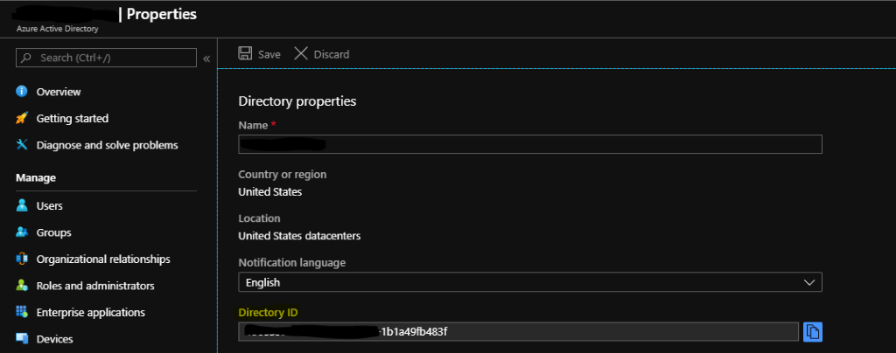
  - Go to the site to consent to WVD, enter the Directory Id you just copied, and click submit.
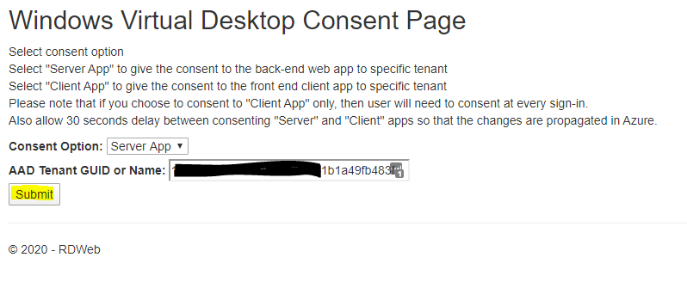
  - You will be prompted to sign in, you must use an account that has been assigned the Global Administrator role.
  - Then click accept on the list of permissions to be granted
  - Repeat this same process, changing the Consent Option drop down box to “Client App.”
- Assign TenantCreator Role to Azure AD Users
  - Navigate to Azure Active Directory, under the Enterprise Applications blade.
  - Find the “Windows Virtual Desktop”, this was created when consent was granted.
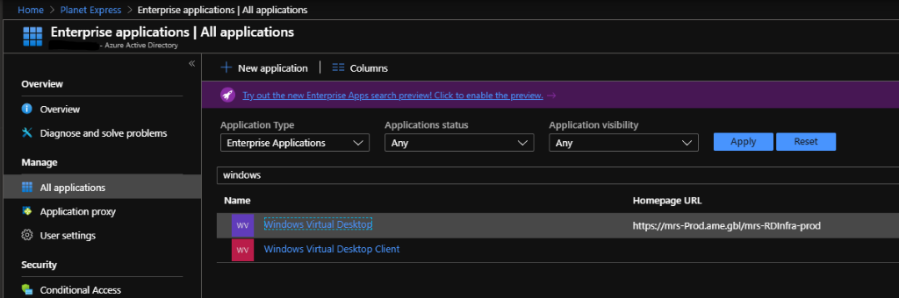
  - Within the application, navigate to the Users and Groups Blade.
  - Add any users that need access, and assign the “TenantCreator” role.
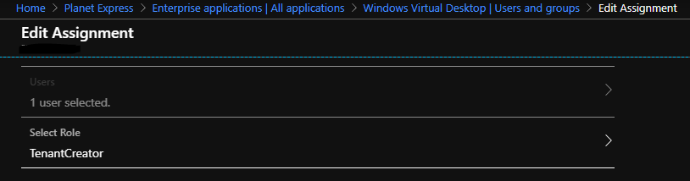
- Create WVD Tenant
  - Open an Administrator Powershell instance
  - Use the following commands to verify the proper modules are installed.
#Verify that the following modules are installed and imported into the current session
Install-Module Az
Import-Module Az
Install-module Microsoft.Rdinfra.RdPowerShell
Import-module Microsoft.Rdinfra.RdPowerShell

  - Use the next commands to authenticate to the RDS powershell service, do not change the URL, and to create your new tenant.
Login-AzAccount
Add-RdsAccount -DeploymentURL https://rdbroker.wvd.microsoft.com
New-RdsTenant -Name "<Create your WVD Tenant name here>" -AadTenantID "<Azure AD Tenant ID used in step 1A>" -AzureSubscriptionID "<ID of Azure Subscription WVD will be deployed in>"

- Create service principal in Azure AD and assign permissions
  - Use the following 3 commands to create a service principal and credentials that will be used to create this hostpool and future hostpools.
$TenantGroupName = "Default Tenant Group"
$TenantName = (get-rdstenant).TenantName #As you used in the previous step

# create the service principal:
$aadContext = Connect-AzureAD
$svcPrincipal = New-AzureADApplication -AvailableToOtherTenants $true -DisplayName "Windows Virtual Desktop Svc Principal"
$svcPrincipalCreds = New-AzureADApplicationPasswordCredential -ObjectId $svcPrincipal.ObjectId
New-RdsRoleAssignment -RoleDefinitionName "RDS Owner" -ApplicationId $svcPrincipal.AppId -TenantName $TenantName

#Continued from last page

$svcPrincipal.AppId
$svcPrincipalCreds.Value
$aadContext.TenantId.Guid

Make note of the value produced by $svcPrincipalCreds.Value and store this in a secure password manager or Azure KeyVault. You will not be able to retrieve this password again after closing powershell.
- Add additional User Accounts as RDS Admins
  - User this command for any WVD administrators that will need to run any administration scripts in this document.
New-RdsRoleAssignment -RoleDefinitionName "RDS Owner" -SignInName "<user@domain.com>" -TenantName $TenantName

- Note: Users with MFA enabled may experience errors running commands even with the RDS owner role assigned. To circumvent this, you need to sign in using the service principal with this command instead. Use the service princpal’s App ID as the username, and the password generated earlier that may be stored in this command, $svcPrinipalCreds.Value, or copy and paste it from the password manager it is stored it.
Add-RdsAccount -DeploymentUrl "https://rdbroker.wvd.microsoft.com" -ServicePrincipal -AadTenantId $aadContext.Tenant.Id.Guid

- Create the Hostpool
  - In the Azure portal, click on the “Create a Resource option.
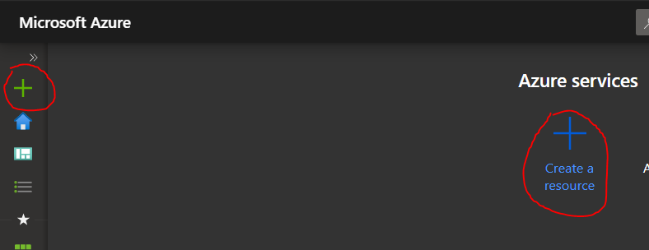
  - Search for “Windows Virutal Desktop – Provision a host pool” then click create
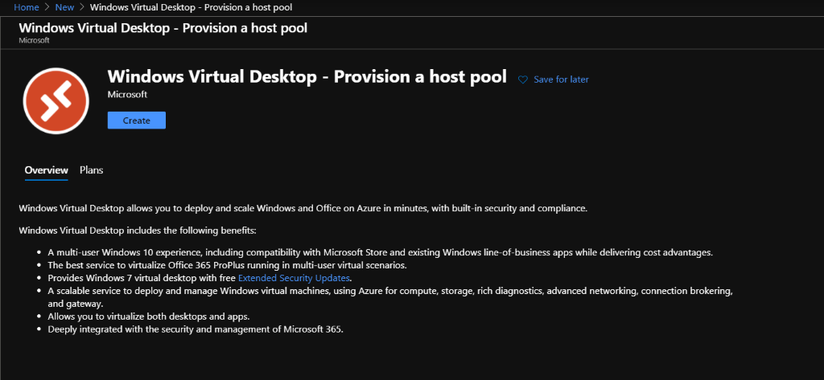

  - Specify the basics of where the host pool will be deployed
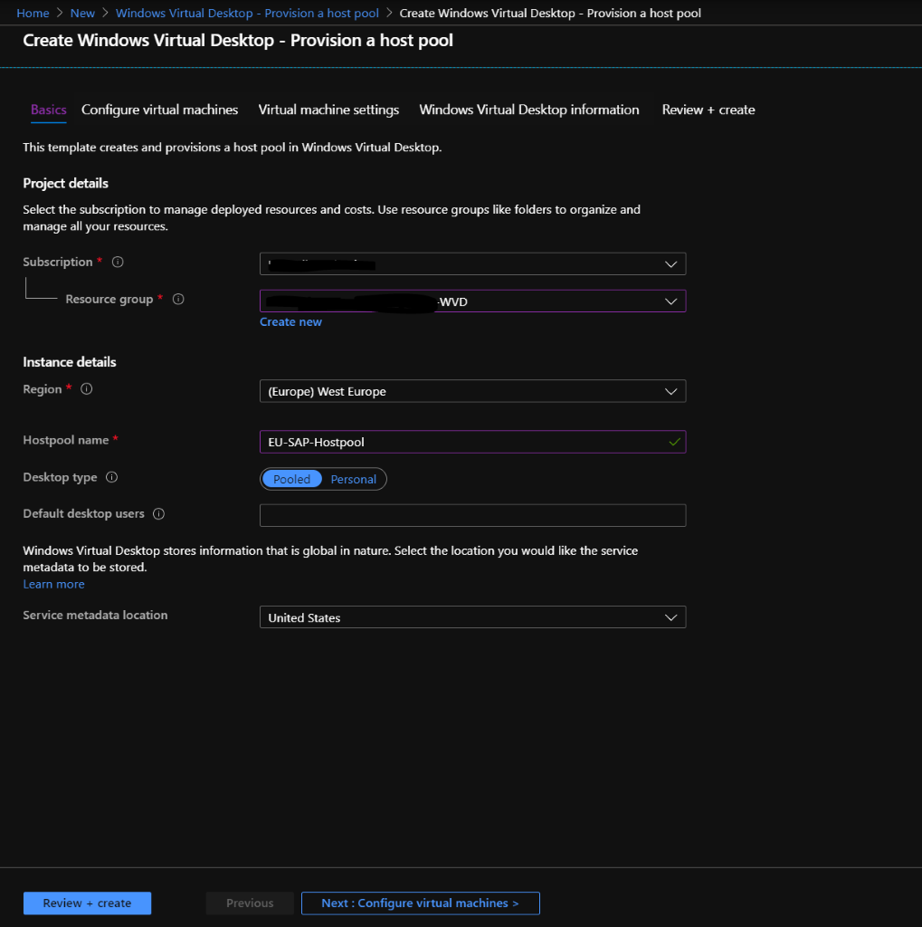
    - Subscription: Make sure to use the same subscription that was used in earlier steps
    - Resource Group: Choose a resource group that will host all the created resources
    - Region: Choose a region that best matches the geographical location of the users that will connect to the hostpool
    - Hostpool name: Create a hostpool name that is unique to your subscription
    - Desktop Type: Choose the option that best matches your needs
      - Pooled: Multiple users will connect to the same VM. Good if you plan on publishing specific remote apps for users rather than full desktops. This option can make use of Windows 10 Multi Session.
      - Personal: Each session host will be assigned to an individual user. This option provides a persistent VM for each user. It will require more VMs than a pooled type, as each VM can only be used by one user at a time.
    - Default desktop users: Enter a comma separated list of users that will be added to the default desktop group at creation. Users can be added after creation of the host pool as well.
    - Service metadata location: At the time of writing, United States is the only option for metadata storage.
  - Configure Virtual Machines
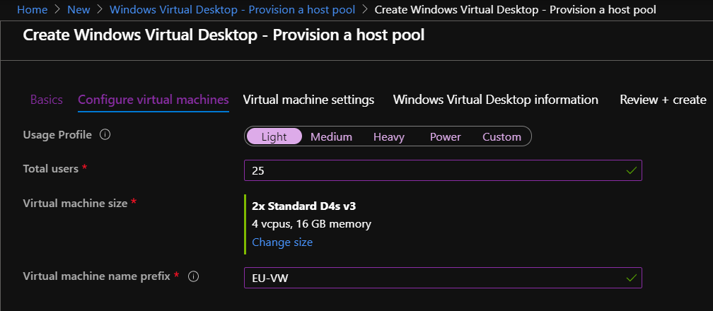
    - Usage Profile: This setting will determine the number of VMs that the hostpool will contain to start with. You can specify a custom number of VMs as well.
    - Total Users: This will determine the number of VMs needed based off a combination of the usage profile and total users
    - Virtual Machine Size: Choose a machine size that will be deployed, this defaults to a standard D4s v3 but can be changed to suit your environment's needs.
    - Virtual machine name prefix: This will determine the naming scheme of the hostpool VMs. For instance, if you named it EU-VW, it would deploy them as EU-VW-0, EU-VW-1, etc.
  - Virtual Machine Settings
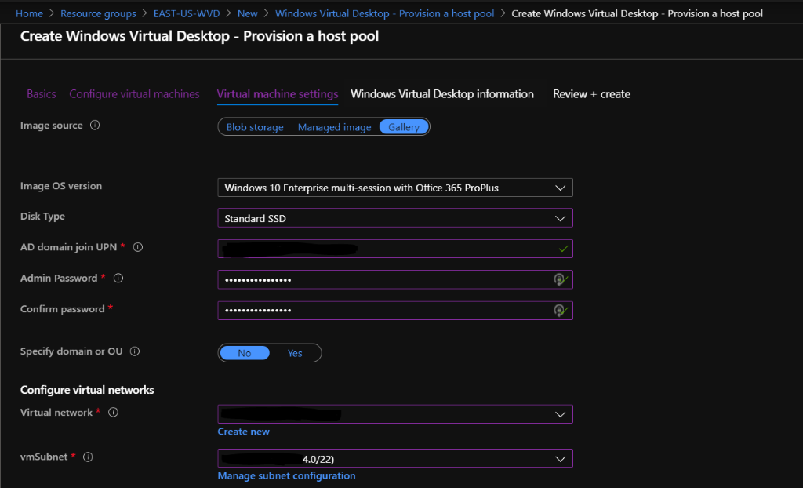
    - Image Source: You can choose an image from the gallery, or a preexisting managed image, or an image stored in blob storage
    - Disk Type: Choose the Disk SKU that will be used for all VMs created
    - AD domain join UPN and Admin Passwords: Specify the UPN and password of an account that can add VMs to the domain
    - Specify domain or OU: You can optionally specify the domain and OU path to join the created VMs to
    - Configure Virtual Networks: Choose an existing Vnet and Subnet for the resources to be deployed to. Note: Even though it gives the option to create a new Vnet in this step, it must be created before provisioning the host pool.

  - Windows Virtual Desktop Information
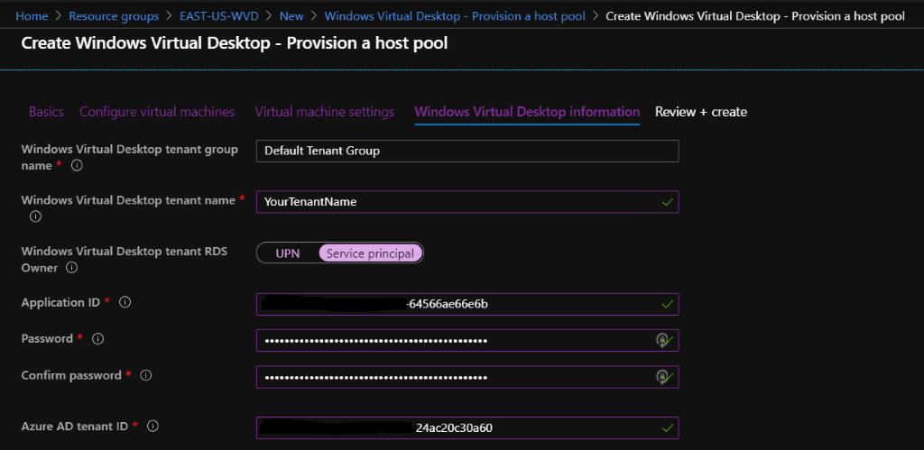
    - Windows Virtual Desktop Tenant Name: This should be left as Default Tenant Group
    - Windows Virtual Desktop Tenant Name: This must be the same as the tenant name created earlier in step 3C
    - It is recommended to use the Service Principal created earlier for this step. To get the Application ID, find the service principal in your Azure Active Directory or run $svcPrincpal.AppID in powershell from earlier
    - For the Service Principal password use the $svcPrincipalCreds.Value in powershell. Or create a secret from Azure active directory from the portal. Make note of this password, you will be unable to retrieve it later.
    - You can get the Azure AD Tenant Id from Azure Active Directory in the portal, or use $aadContext.TenantId.GUiD in powershell.
    - Review and Create: Verify that all settings are correct and that there are no validation errors. The provisioning process can take anywhere from 20 minutes to an hour depending on how many VMs are being deployed.

- Test connection
  - Navigate to https://rdweb.wvd.microsoft.com/webclient/index.html in your browser. Sign in with one of the accounts you specified as a default Desktop user during step 5C. From here, there should be a default session you are able to connect to and use as a standard Windows workstation.
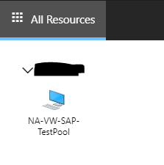
  - Connecting to this workstation will prompt you to allow the clipboard and printers to be shared to the Virtual desktop. Once you allow or deny this, you will be prompted for domain credentials, the same that was used to sign into the web portal.
  - Alternatively, you may download the desktop client here https://docs.microsoft.com/en-us/azure/virtual-desktop/connect-windows-7-and-10

Additional Administration Steps
- Add or remove Users to a desktop or application group
  - Back to the same powershell session from earlier, use these commands to add and remove users from groups in the RDS Hostpool
$TenantGroupName = "Default Tenant Group"
$TenantName = (get-rdstenant).TenantName
$hostpoolname = "<Hostpool name you created in step 5.C.iv>"
Add-RdsAppGroupUser -TenantName $TenantName -HostPoolName $hostpoolname -AppGroupName "<name of application group>" -UserPrincipalName "<UPN here>"

#To Remove a user

Remove-RdsAppGroupUser -TenantName $TenantName -HostPoolName $hostpoolname -AppGroupName "<name of application group>" -UserPrincipalName "<UPN here>"

  - NOTE: A user can not be a member of the desktop application group and a remote app group. However, a user can be a member of multiple remote app groups
- Create a new RemoteApp Group
  - Run this command to create a new RemoteApp Group
New-RdsAppGroup -TenantName $TenantName -HostPoolName $hostpoolname -name "<RemoteAppGroupName>" -Description "<An optional friendly description for the app group if needed>"

- Publish remote apps to a group
  - Use the following commands to return a list of all apps that are available to be remote published.
$appgroupname = "<RemoteAppGroupName from step 2.A>"
Get-RdsStartMenuApp -TenantName $TenantName -HostPoolName $hostpoolname -AppGroupName $appgroupname

#alternatively, run this command to return only the app names rather than the entire information block for each
Get-RdsStartMenuApp -TenantName $TenantName -HostPoolName $hostpoolname -AppGroupName $appgroupname | fl AppAlias

  - Use the following command to publish an app based off its AppAlias, in this example we will use Microsoft Word.
New-RdsRemoteApp -TenantName $TenantName -HostPoolName $hostpoolname -AppGroupName $appgroupname -Name Word -AppAlias Word
#Alternatively, use this command to install an app without an alias or to install it manually
New-RdsRemoteApp -TenantName $TenantName -HostPoolName $hostpoolname -AppGroupName $appgroupname -Name Word –Filepath “<filepath>” -Icon “<filepath to the Icon>” -IconIndex “<filepath to the icon index>”
  - Removing an App will use the exact same commands but with Remove-RdsRemoteApp Instead of New-RdsRemoteApp
  - To check if the app has been successfully published, navigate back the Remote Desktop Web Client and refresh the page. If the account you are signed into is a member of the app group, you should see your published app here.
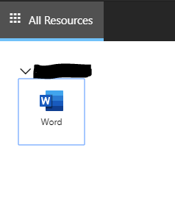
- Configure the HostPool Load Balancer
  - By Default, the HostPool is set to use to a Breadth-first type of load balancer, meaning that users will be evenly spread across all VMs in a hostpool. The other option is a depth-first load balancer, which will put users on a single VM until it hits the Max Session Limit that you set with the load balancer type.
  - To set a Depth-first load balancer, use the following powershell command:
set-rdshostpool -TenantName $tenantname -name $hostpoolname -DepthFirstLoadBalancer -MaxSessionLimit 99
  - To reset back to a Breadth-first load balancer, use this command Instead:
set-rdshostpool -TenantName $tenantname -name $hostpoolname -BreadthFirstLoadBalancer
- Create a managed image in Azure
  - Login to the VM that you wish to use to create the image to deploy to WVD hosts

  - It is recommended that you create a Snapshot of the VM's OS disk before the next steps
  - Open Command prompt as an administrator
    - Navigate to the c:\windows\system32\sysprep directory
    - Use the command sysprep.exe
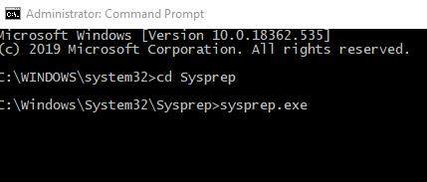
    - Make sure to check the box next to generalize and set the shutdown options to Shutdown
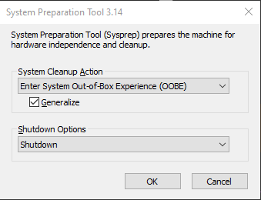
    - After you click ok, the VM should automatically shut down and be ready for image capture.
  - Navigate to the shutdown VM in Azure then use the capture option
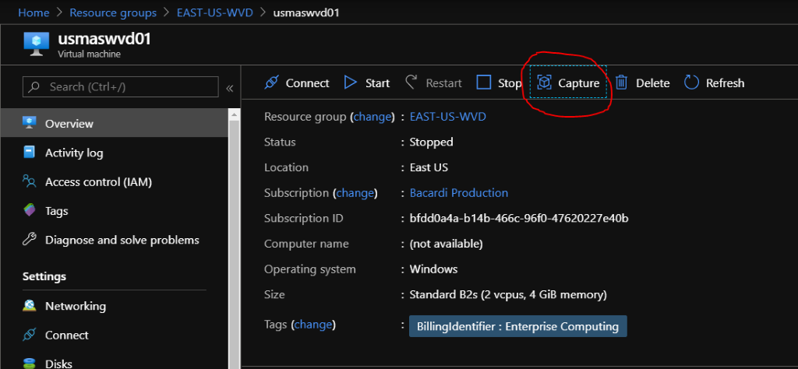
    - Enter the name and resource group of the image you are creating.
    - You can optionally check the box to automatically delete this virtual machine after creating the image
  - Type the virtual machine name that is being used to create the image to proceed then click create
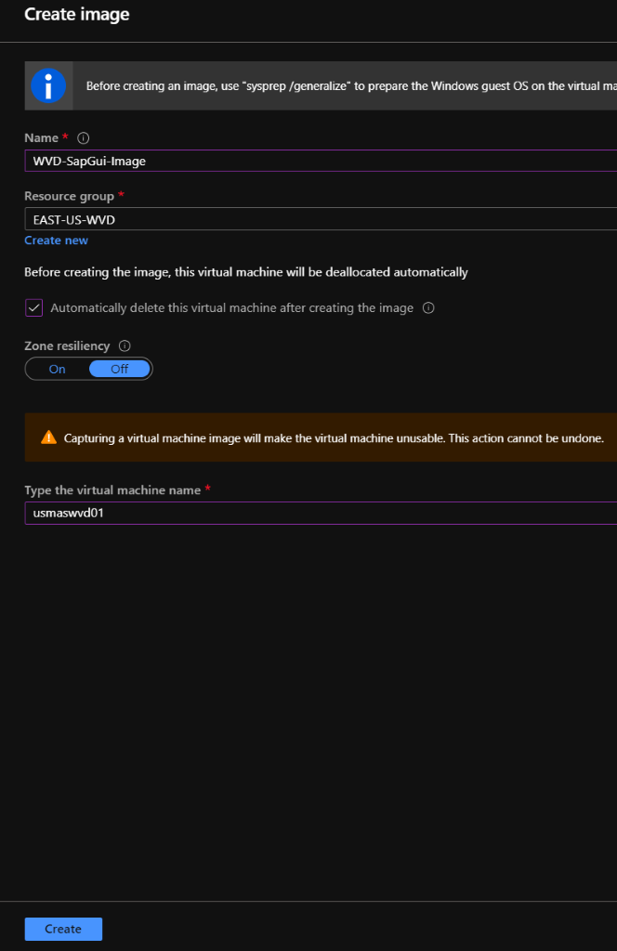
  - Note: you cannot use the managed Image to deploy VMs In a different region than where the Image Is located. An Image will need to be created In each region you are going to deploy WVD to.

- Expand an existing HostPool
  - The best way to expand a host pool is to find your previous deployment and use this to “redeploy” the host pool with additional VMs.
  - In the Azure portal, go to the resource group of the original host pool deployment, and within the settings, choose deployments
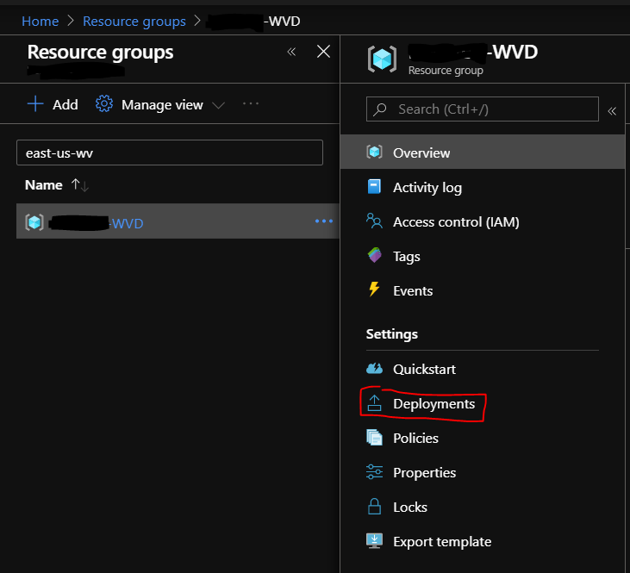
  - From here, you will want to choose the deployment name that starts with “rds.wvd.provision-host-pool”
  - Choose the “redeploy” option at the top
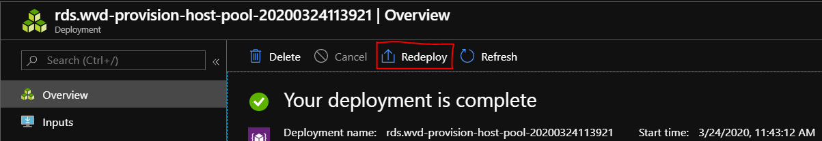
  - You will have to leave most of these fields the same as the original deployment, otherwise the deployment will fail.
  - The following are the settings that require change/updating:
    - Resource group: There is a known issue that the custom deployment will throw an error on the resource group as pictured below. To fix this, choose a different RG, then go back to the correct one.
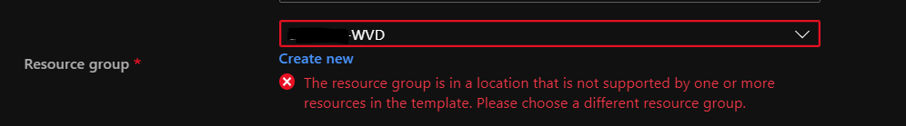
    - _artifacts Location: This is not marked as a necessary change but the value must be updated to match this exact URL every time. https://raw.githubusercontent.com/Azure/RDS-Templates/master/wvd-templates/
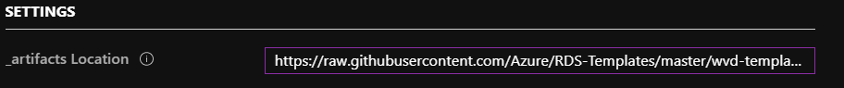
    - RDsh Number of Instances: This is the main field that needs to be changed. Update the number here to the number of VMs that you need in this hostpool. EX: changing the number from 5 to 8, the end result will be 8 VMs in the hostpool.
    - Existing Domain Password: Re-enter the password for the Existing Domain UPN that was originally used to deploy the hostpool.
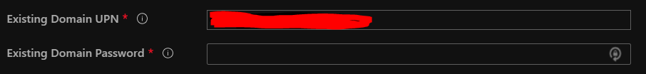
    - Tenant Admin Password: Re-enter the password used with the service principal from the original deployment.
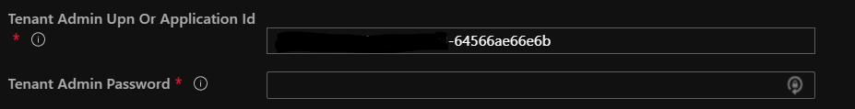
    - Once these fields are filled, check the I agree box then click purchase.
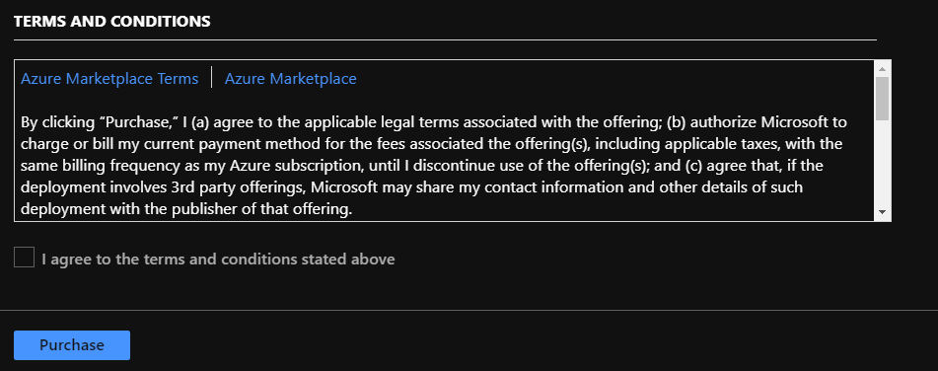
- Resize the VMs in an existing Host Pool
- In the Azure Portal, shut down all virtual machines associated with the host pool.
- Resize all of the VMs to the exact same size, then start them all again.

